**Education Organization Using ServiceNow**

**Team Id:** NM2025TMID18703

**Team Members:**4

**Team Leader:** DHANALAKSHMI M

**Team Member:** DEEPIKA B

**Team Member:** YUVASREE S

**Team Member:** PRIYANKA R

**DEPARTMENT:** COMPUTER SCIENCE

**COLLEGE NAME:** L.N GOVERNMENT COLLEGE OF ARTS & SCIENCE

**YEAR:** 3rd YEAR

**PROBLEM STATEMENT:**

Managing students, faculty, courses, and administrative workflows in an educational organization through manual or disconnected systems is time-consuming, error-prone, and lacks transparency. There is a need for a centralized and automated platform to streamline processes, improve communication, and enhance efficiency.

**OBJECTIVE:**

1. **Centralized Student Information Management**
   * Maintain and manage student profiles, admissions, and academic records in a single ServiceNow platform.
2. **Automated User & Role Management**
   * Create, manage, and assign roles (students, teachers, administrators) efficiently with ServiceNow workflows.
3. **Streamlined Academic Processes**
   * Automate tasks such as course registration, timetable management, and grading to reduce manual work.
4. **Improved Communication & Collaboration**
   * Provide a centralized portal for announcements, queries, and notifications between faculty, students, and staff.
5. **Efficient Request & Incident Handling**
   * Allow students and staff to raise requests (e.g., IT support, facility issues, academic queries) and track resolutions through ServiceNow’s ticketing system.
6. **Data-Driven Decision Making**
   * Use ServiceNow dashboards and reports to monitor student performance, resource usage, and institutional efficiency.
7. **Enhanced Transparency & Accountability**
   * Ensure clear visibility of academic and administrative processes to both staff and students.
8. **Scalability & Adaptability**
   * Provide a flexible platform that can grow with the institution and support new modules (exams, library, hostel, etc.) when required.

**SKILLS:**

**• ServiceNow Platform Skills**

* Hands-on experience in navigating the ServiceNow interface.
* Creating and managing users, groups, and roles.
* Designing and configuring workflows for academic and administrative processes.

**• IT Service Management (ITSM) Skills**

* Incident, problem, and request management for handling student and staff queries.
* Knowledge of ticketing systems and escalation processes.

**• Database & Record Management**

* Understanding of ServiceNow tables and records.
* Managing student, teacher, and administrative data securely.

**• Scripting & Customization Skills**

* Using ServiceNow scripting (JavaScript/Glide scripting) for customization.
* Implementing automation to reduce manual work.

**• Reporting & Dashboard Skills**

* Creating visual dashboards for monitoring student progress, faculty workload, and request status.
* Generating data-driven reports for decision-making.

**• Analytical & Problem-Solving Skills**

* Analyzing institutional needs and mapping them to ServiceNow capabilities.
* Optimizing workflows to improve efficiency.

**• Collaboration & Communication Skills**

* Coordinating tasks among team members.
* Communicating effectively with stakeholders (teachers, administrators, students).

**TASK INITIATION**

**Milestone 1: Setting Up ServiceNow Instance**

**Activity 1: Setting up ServiceNow Instance**

* 1. Sign up for a developer account on the ServiceNow Developer site “https://developer.servicenow.com”.
  2. Instance Once logged in, navigate to the "Personal Developer " section.
  3. Click on "Request Instance" to create a new ServiceNow instance.
  4. Fill out the required information and submit the request.
  5. You'll receive an email with the instance details once it's ready.
  6. Log in to your ServiceNow instance using the provided credentials.
  7. Now you will navigate to the ServiceNow.

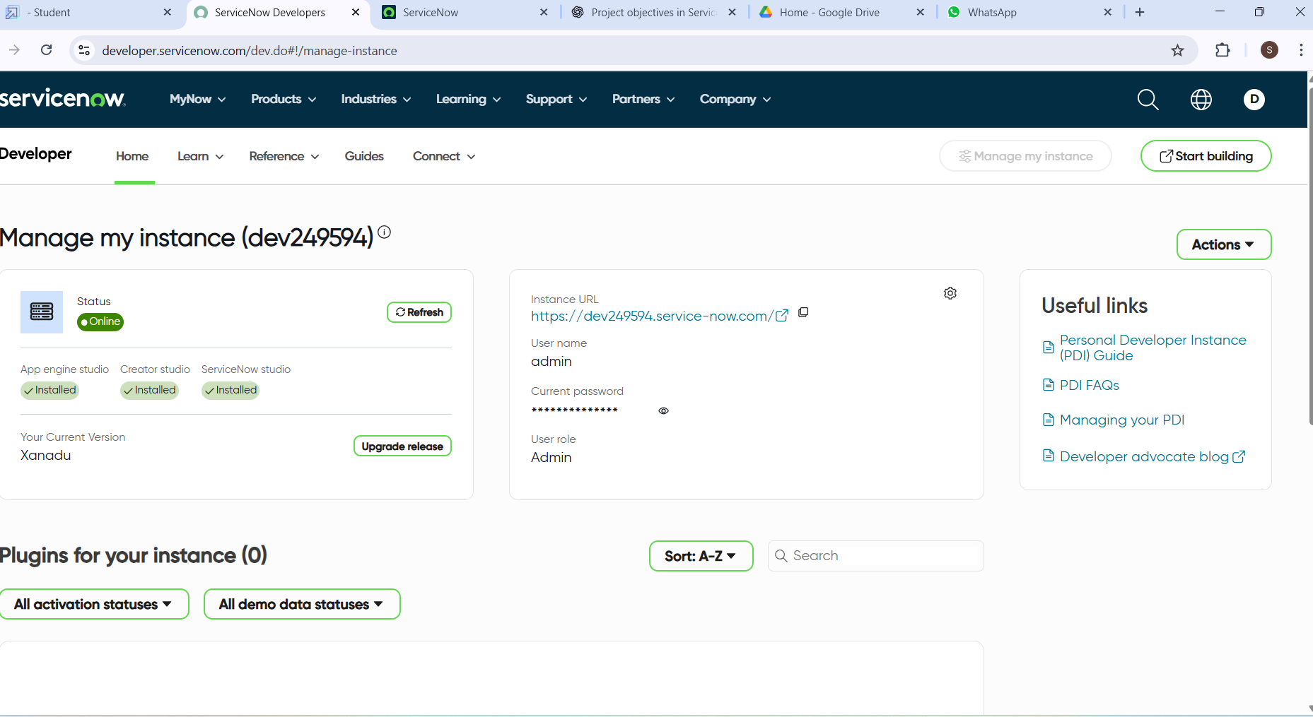

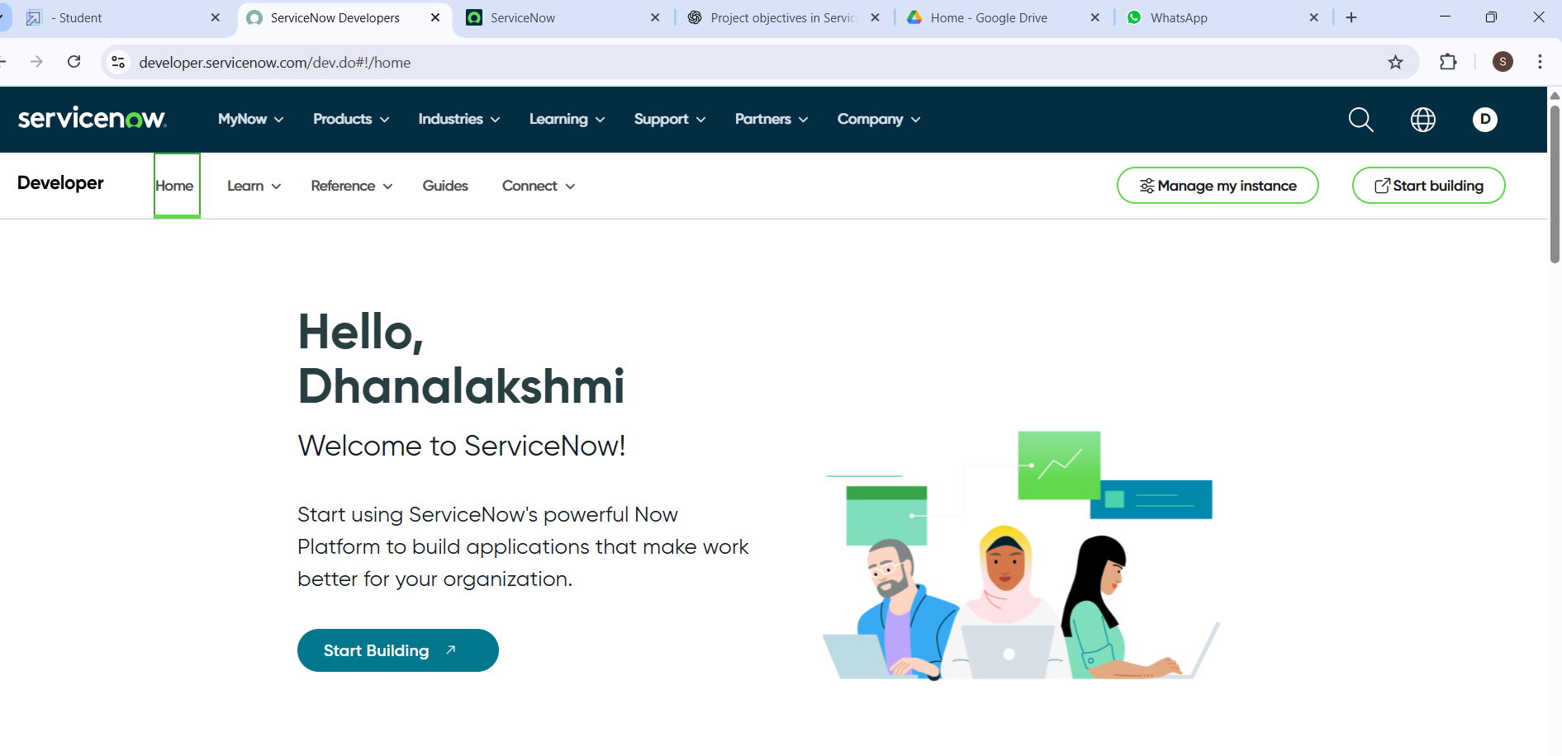

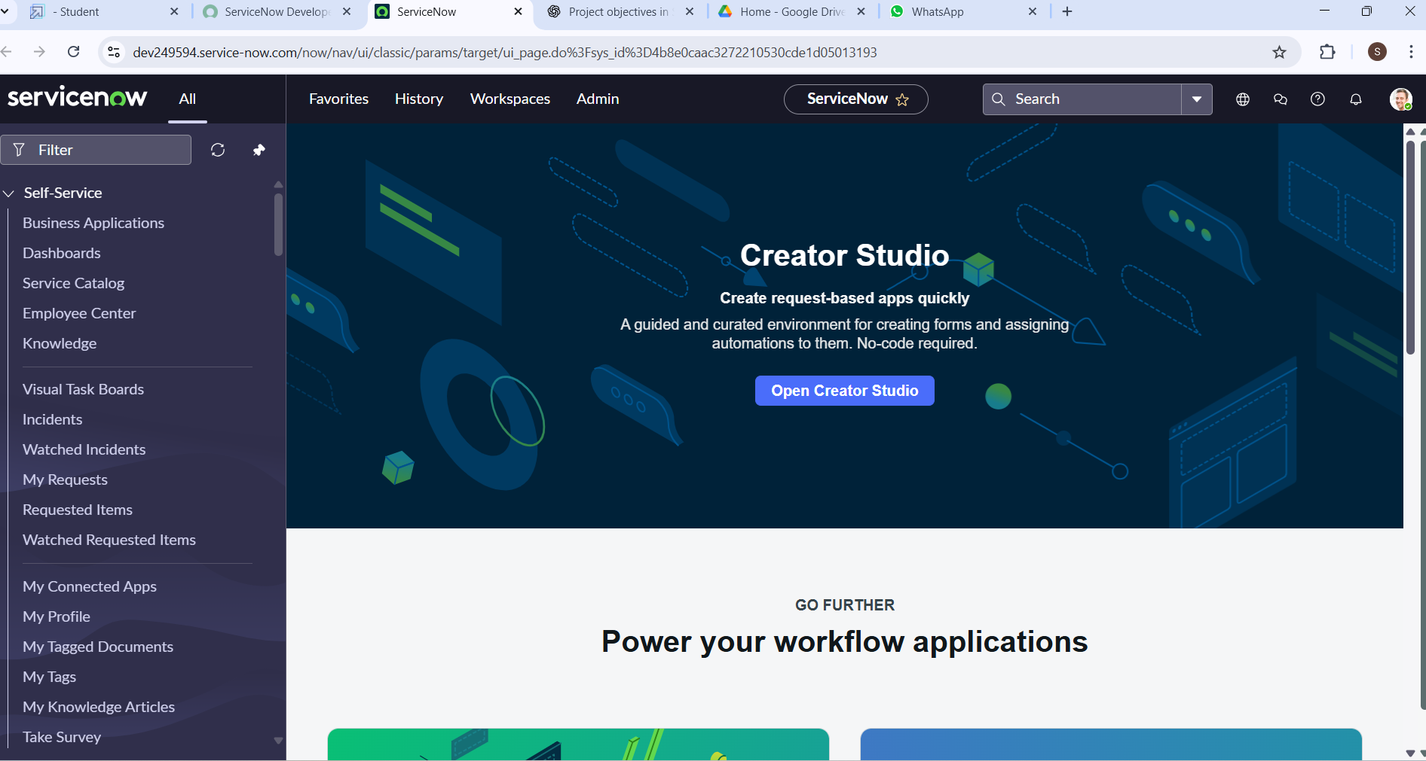

**Milestone 2: Creating A Update Set**

**Activity 1: Creating A Update Set**

* 1. Click on All >> Local update sets .

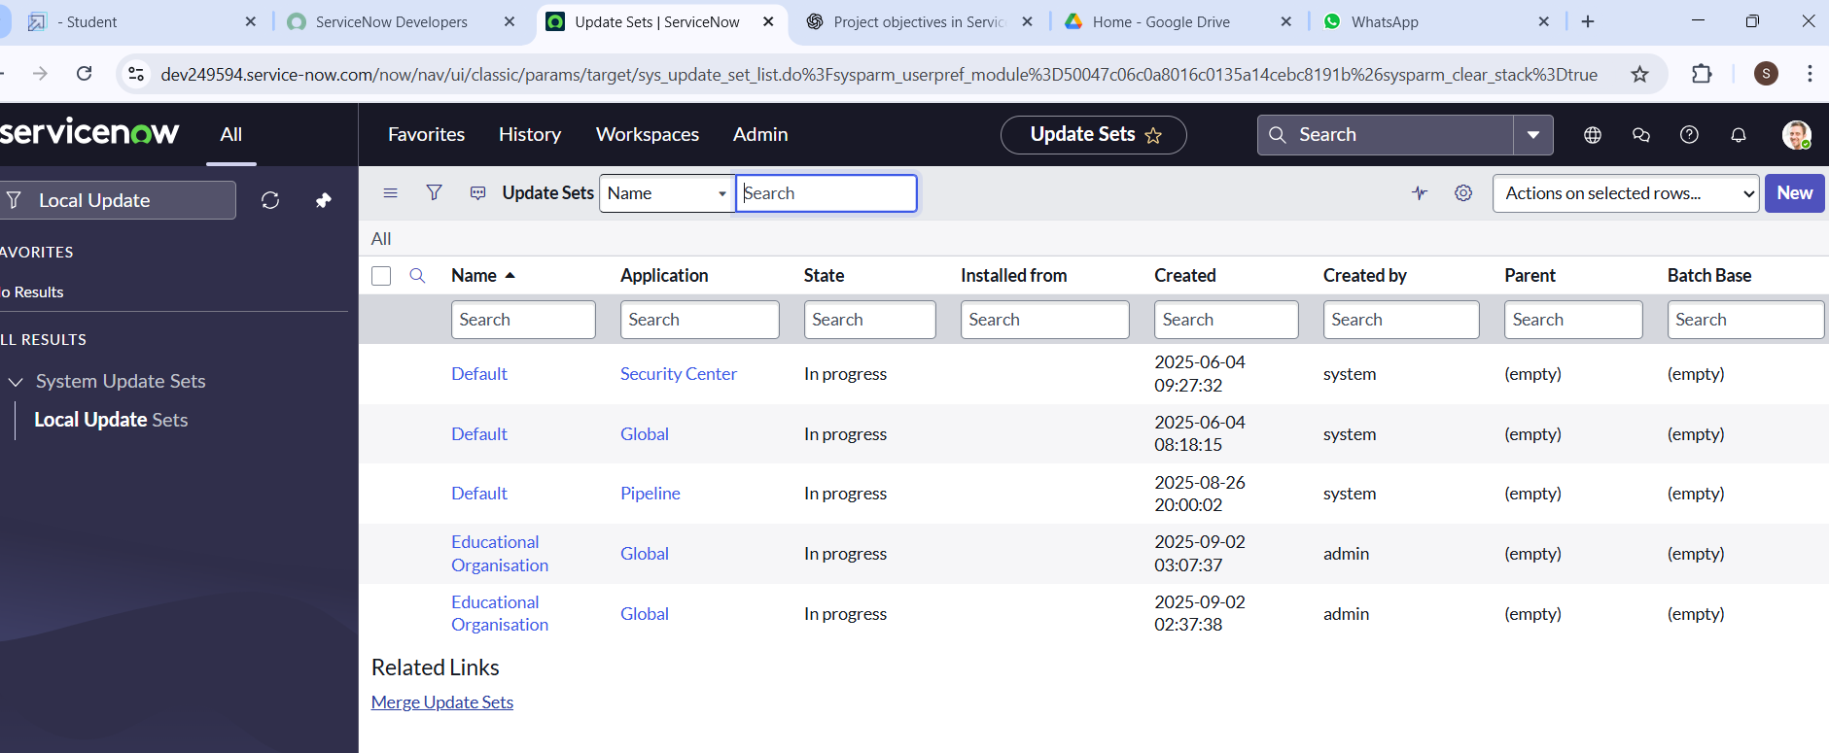

* 1. Click on new



* 1. Enter the Details Name: Educational Organisation >> Click on Submit and make Current.

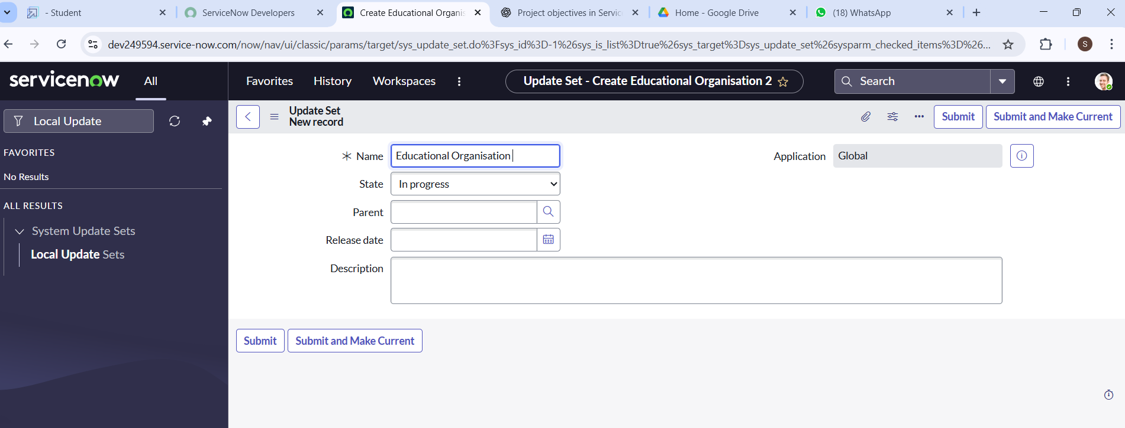

**Milestone 3: Creating a Table**

**Activity 1:** **Creating Salesforce Table**

* 1. All >> Tables.

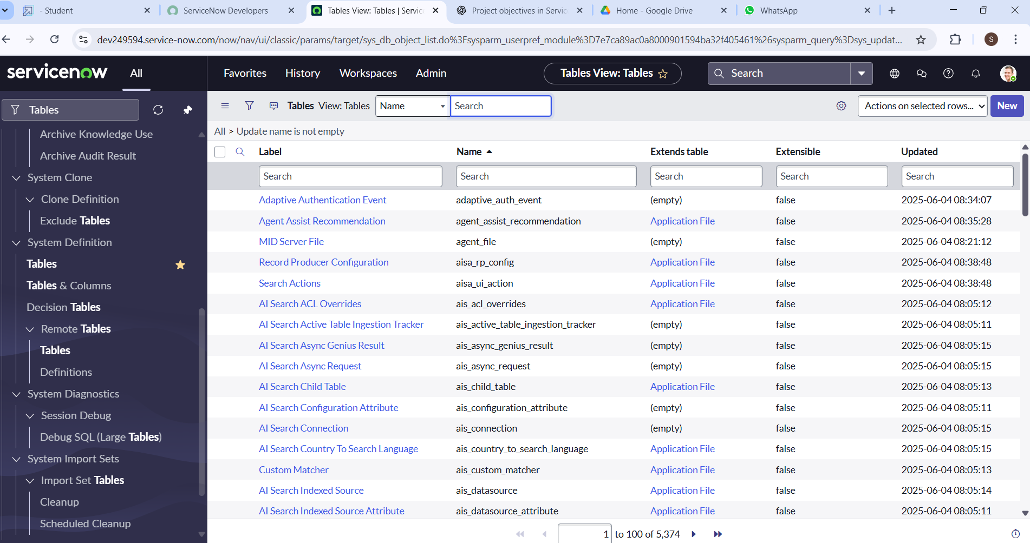

* 1. Click on new



* 1. Enter the Label(Anything you want): EduTech Program Team>> Click on Name it will Automatically generate Api name.

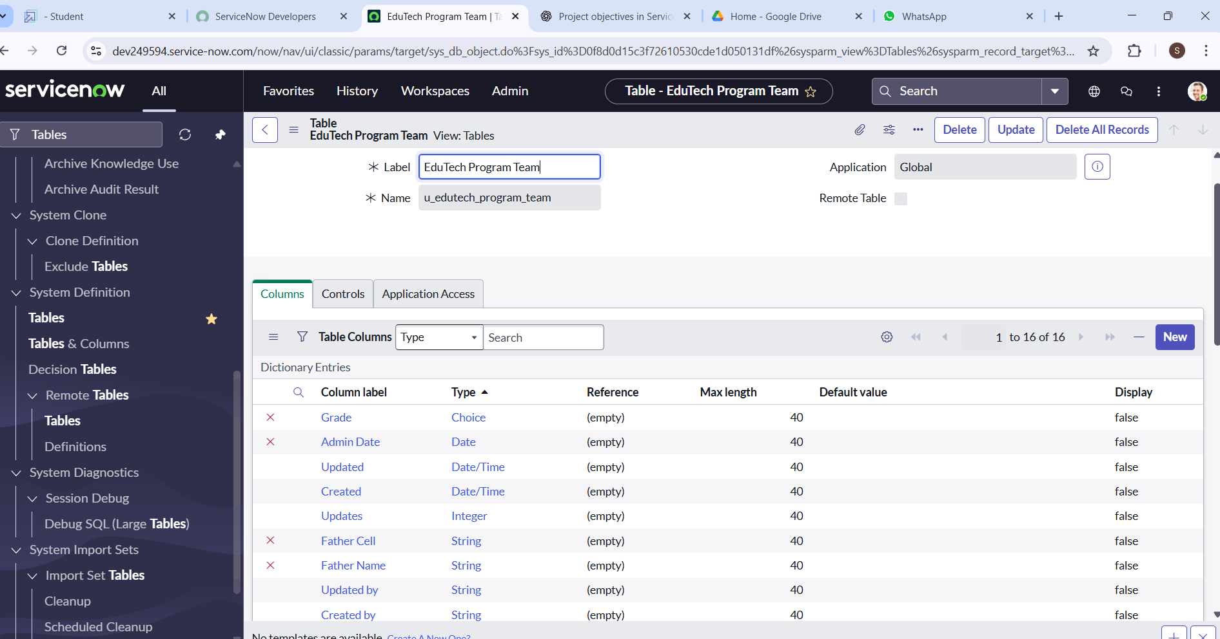

* 1. Create columns as given below, Double Click on Column label and Enter the Column labels and click on the tick mark >> Give Type as given .

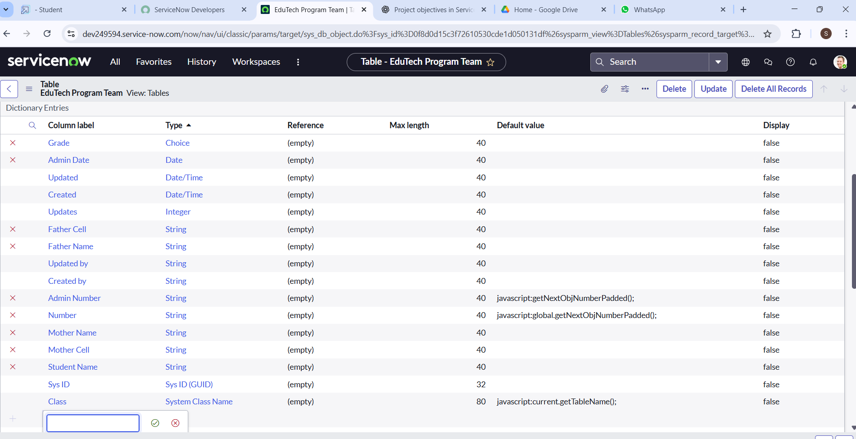

* 1. For “Admin Number” Give Display as True and right click on the toggle bar on top >> save.

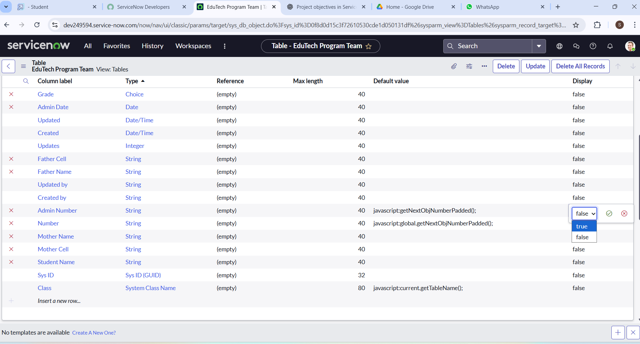

* 1. Click on controls >> Enable Extensible.

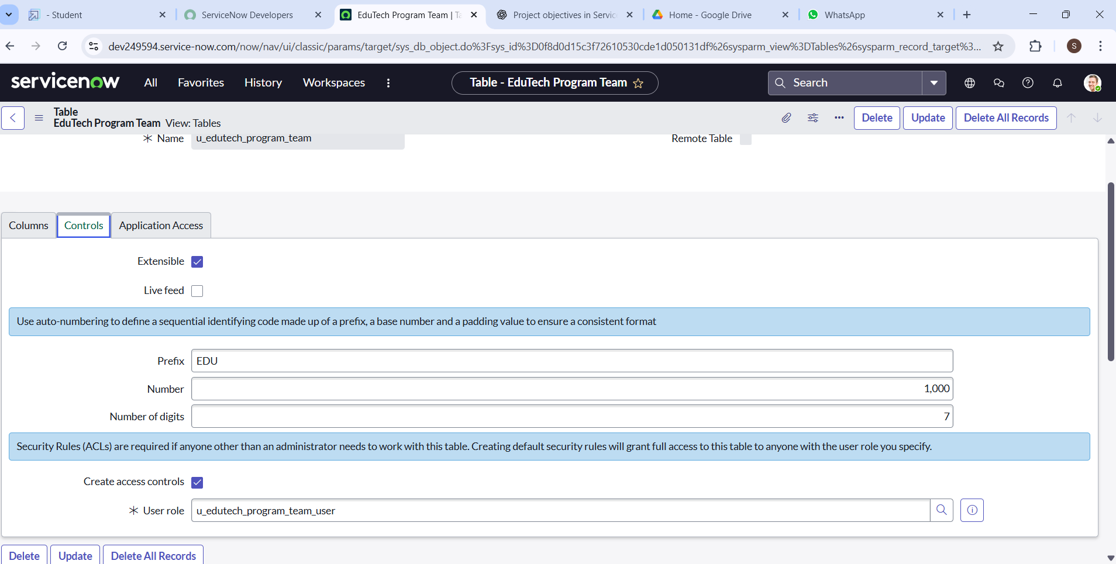

* 1. Click on “Admin Number” column, In Related Links Click on Advanced View >> Default View (Enable Use dynamic default) >> select Get Next Padded Number in Dynamic default value >> Update .

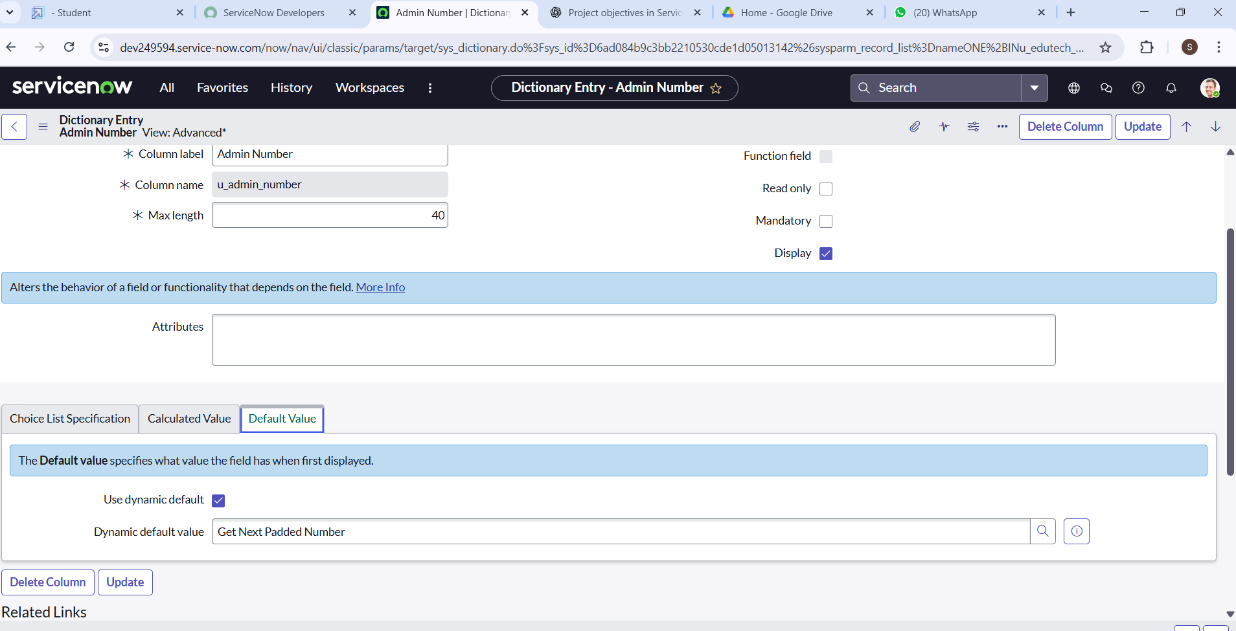

* 1. Click on “Grade” Column >> Click on Choices and give Label,Value and Sequence as given below.

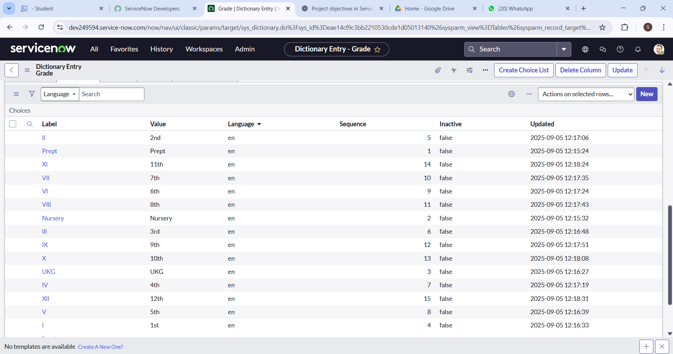

**Activity 2: Creating Admission Table**

1. Create an Admission Table with Columns given.

2. Select Extends Table >> Salesforce and also Select Add module to menu >> Salesforce.

3. Create Fields as shown

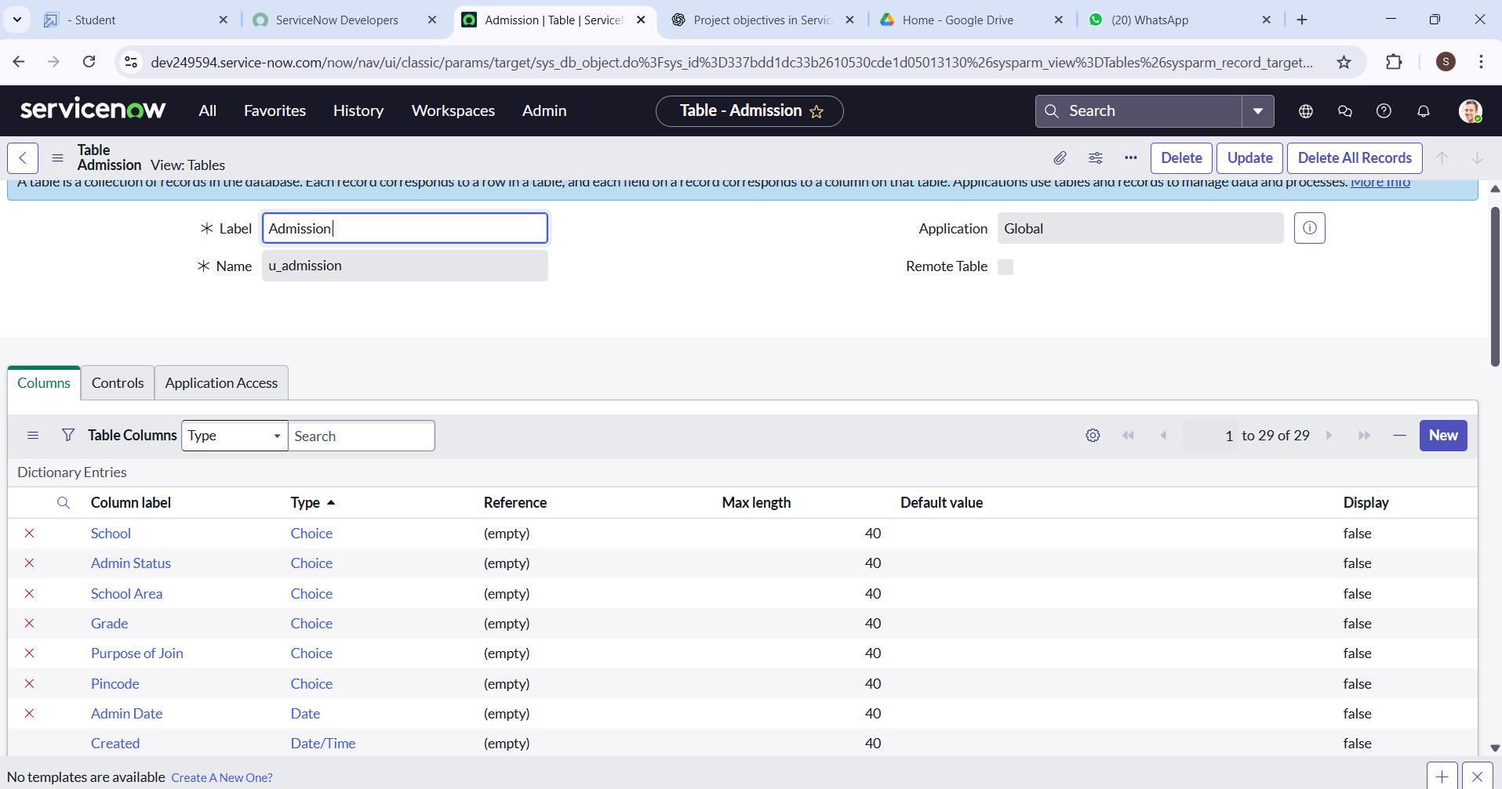

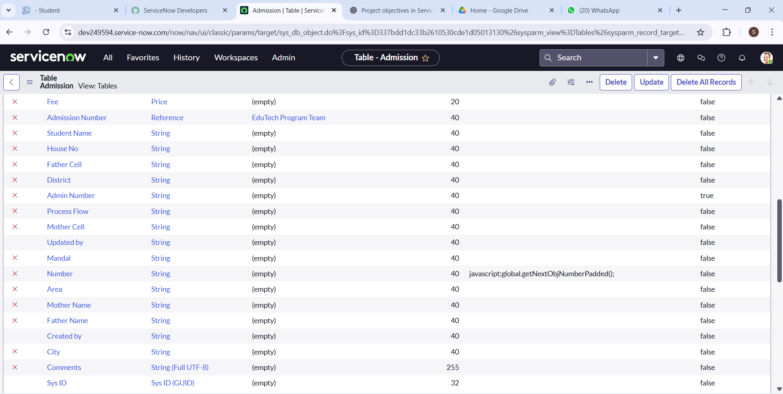

* 1. Create choice for Admin Status as:

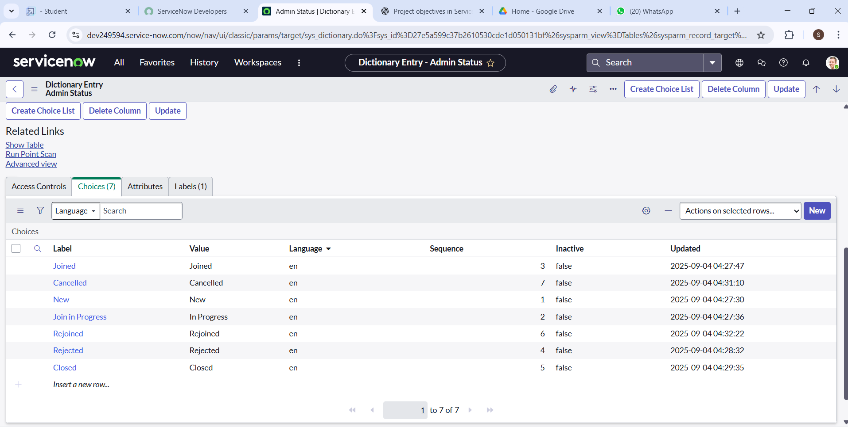

* 1. Create choice for Pincode as:

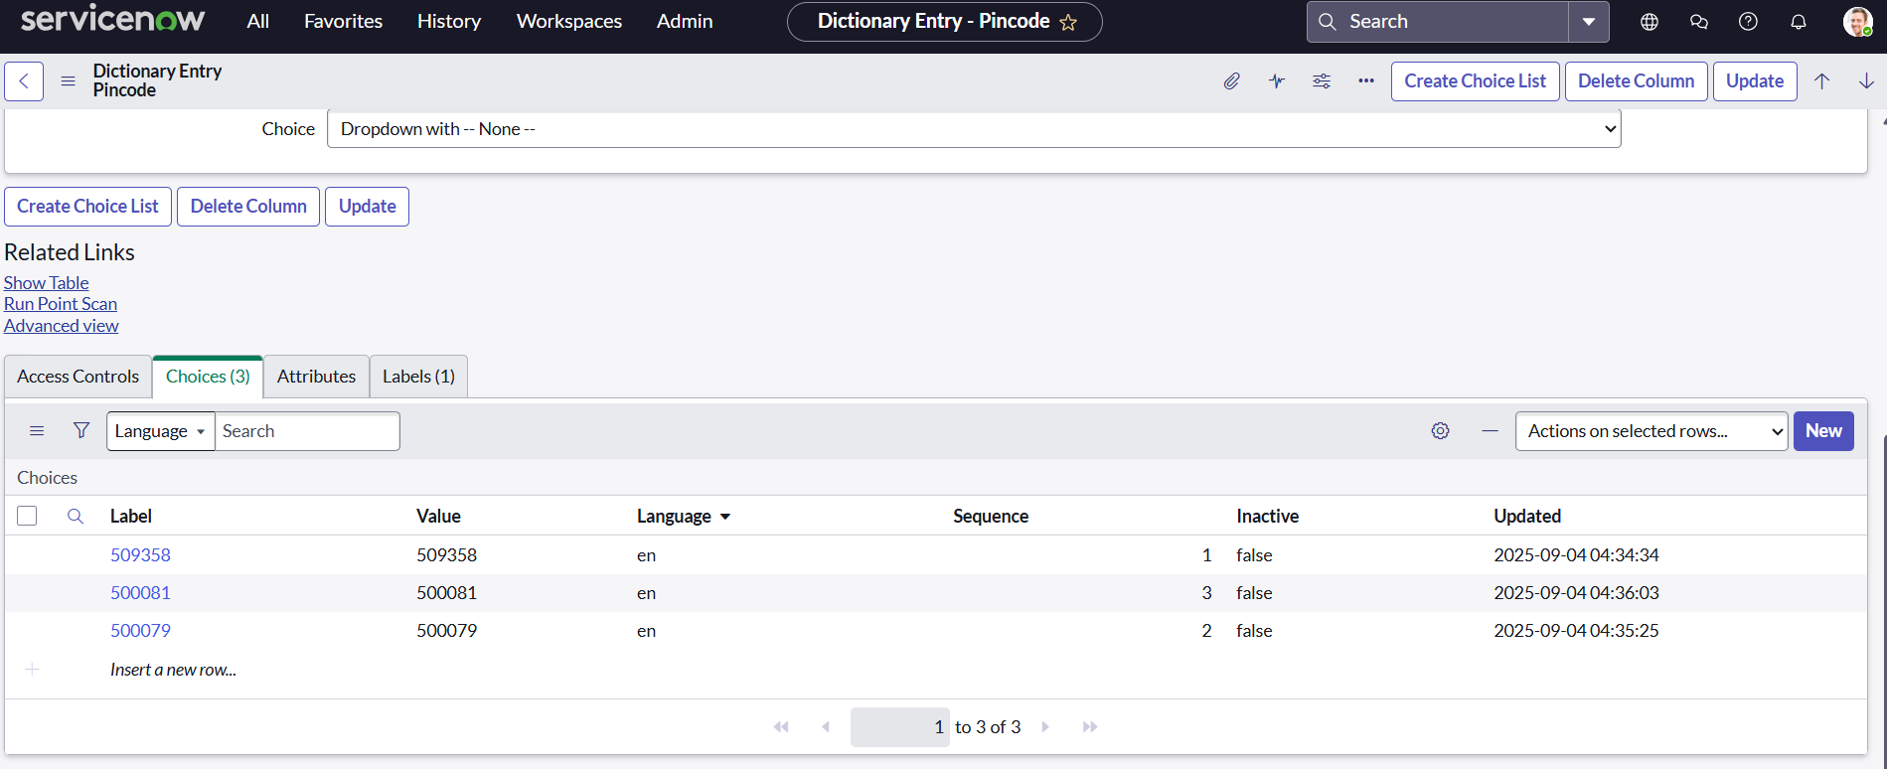

* 1. Create choice for Purpose of Join as:

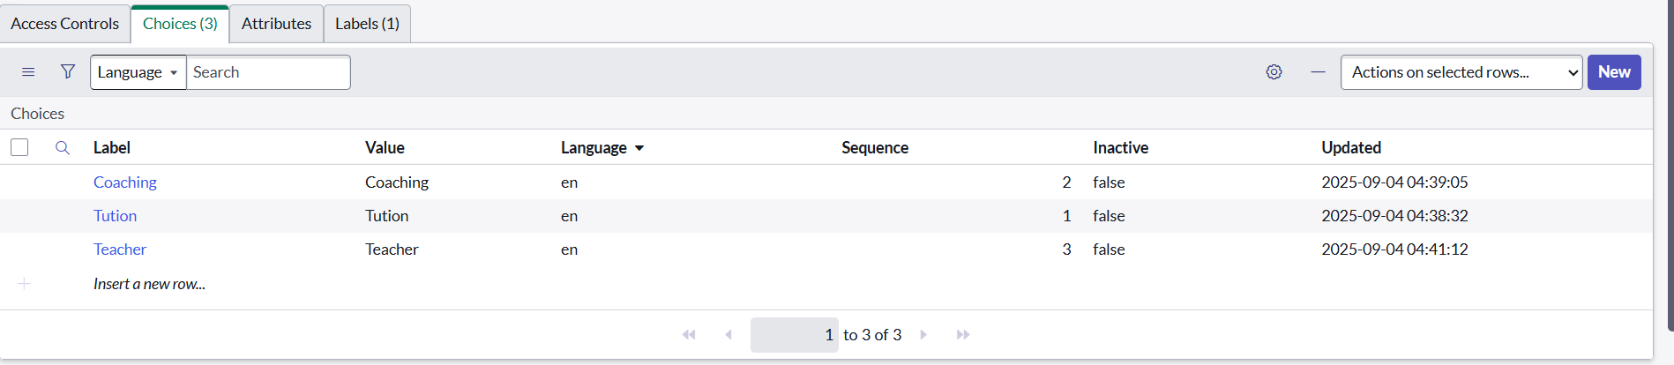

* 1. Create choice for School as:

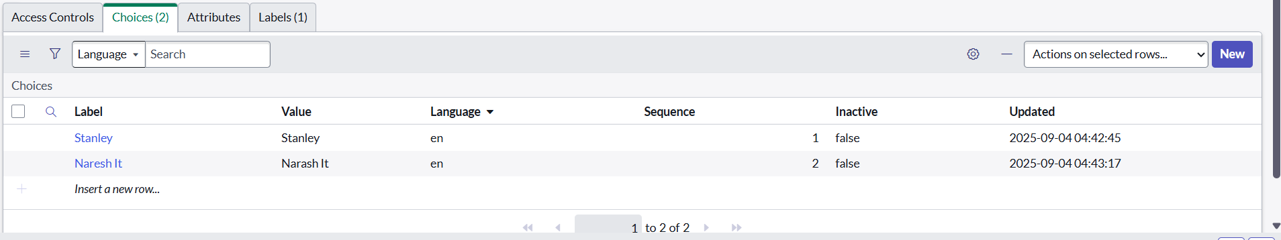

* 1. Create choice for School Area as:

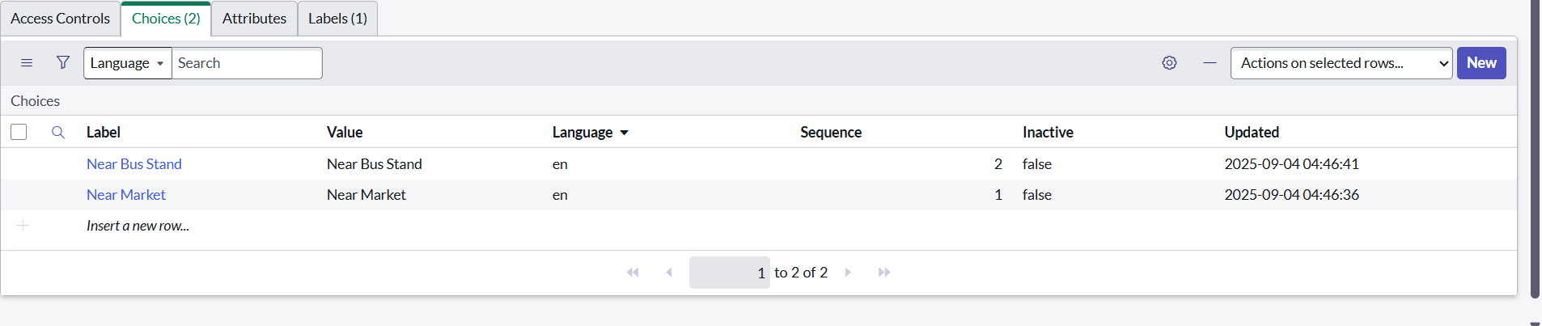

**Activity 3: Creating Student Progress Table**

1. Create a Student Progress Table with Columns given.
2. Select Add module to menu >> Salesforce.
3. Create Fields as shown:

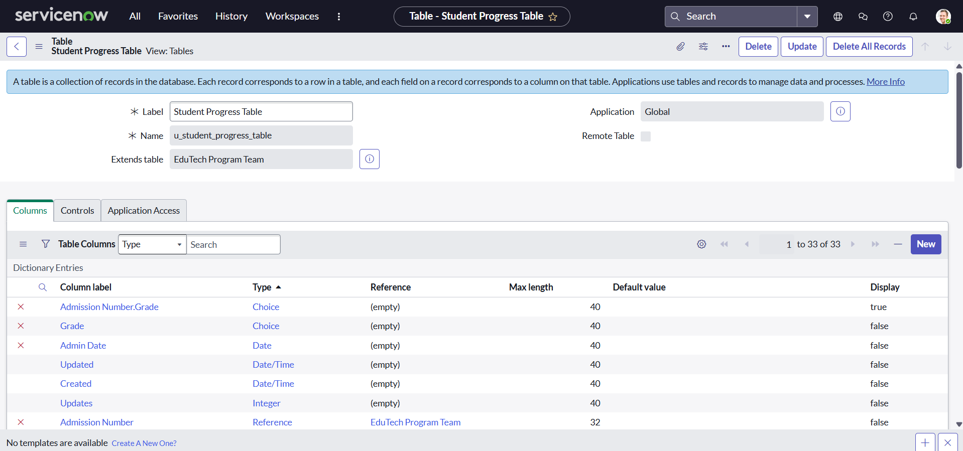

**Milestone 4:** **Form Layout**

**Activity 1: Configuring Table form for Student Progress Table**

* 1. In the Student Progress Table Page , Click on Layout form .

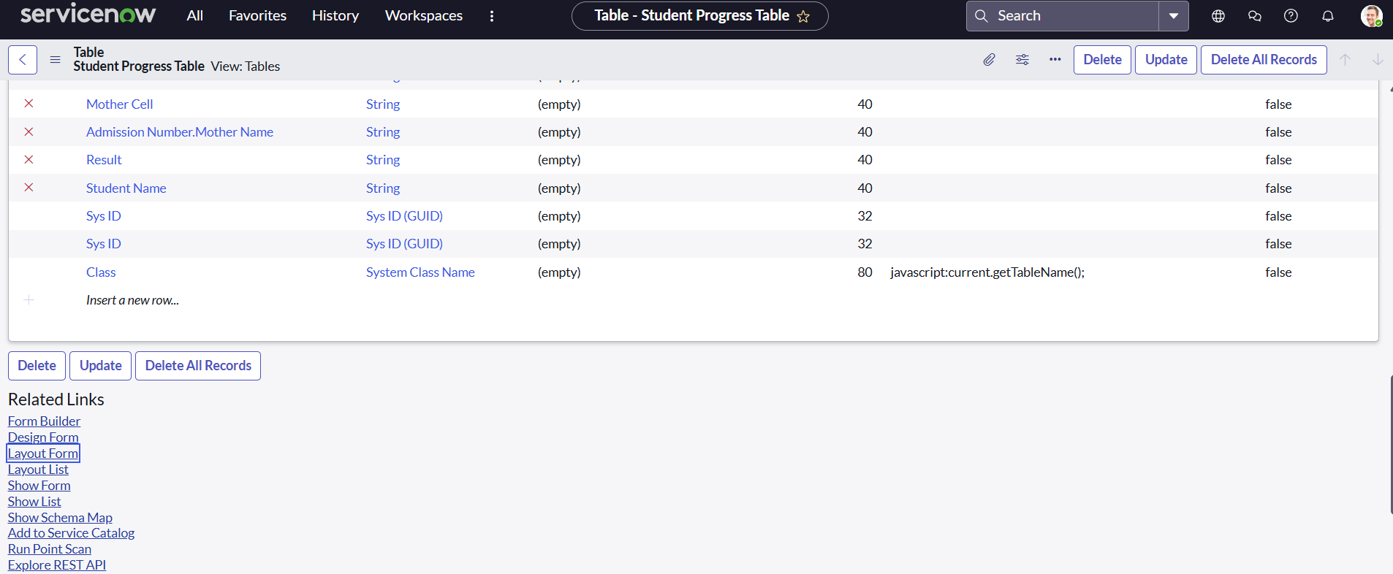

* 1. Click on Admission Number [+] **.**

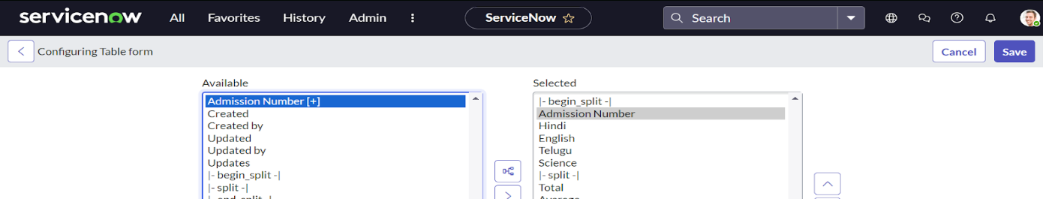

* 1. Select below Admission Number fields in Available side and send it to selected side as below >> save.

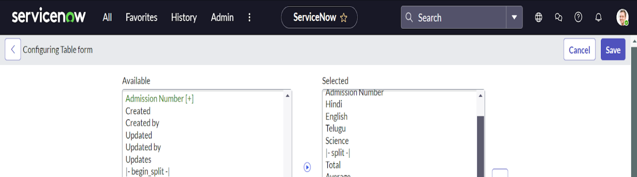

**Milestone 5: Form Design**

**Activity 1:** **Creating Form Design for EduTech Program Team Table**

1. All >> System Definition >> Tables .
2. In Label Search for EduTech Program Team and open .

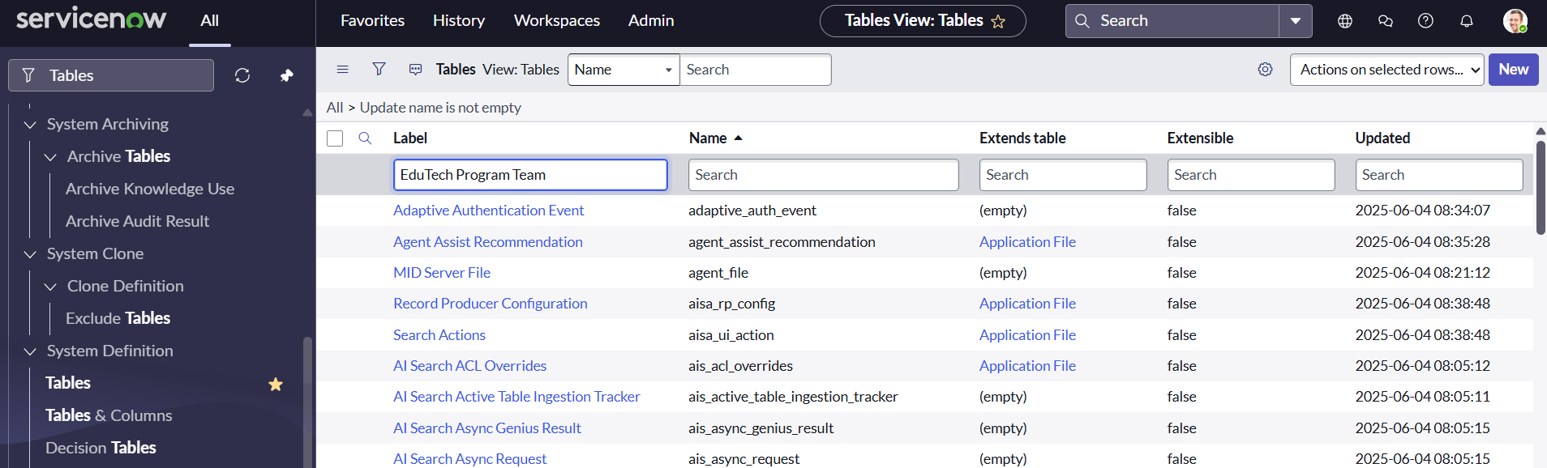

1. Right Click on top Toggle >> Configure >> Form Design.

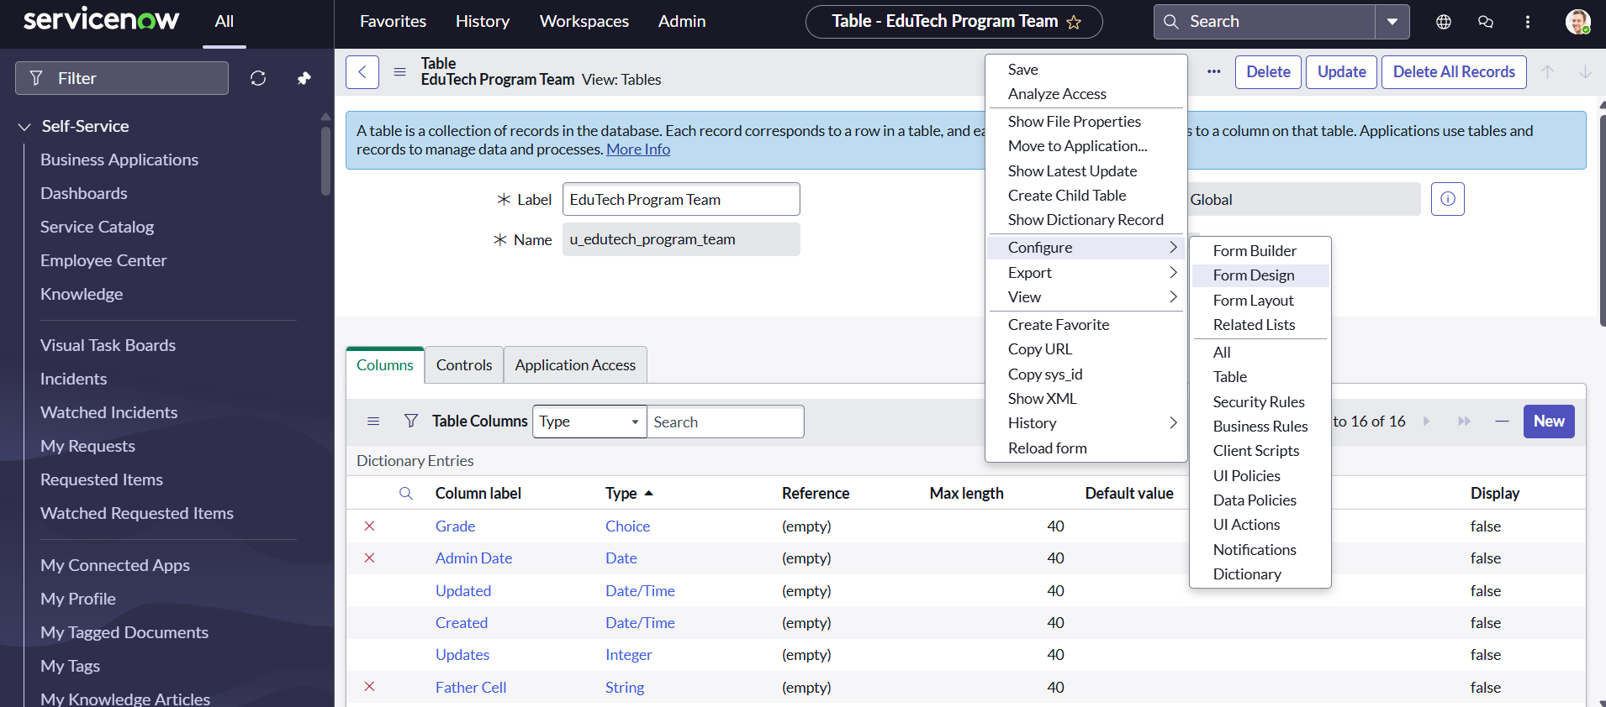

1. In drop down select EduTech Program Team(u_edutech_program_team)

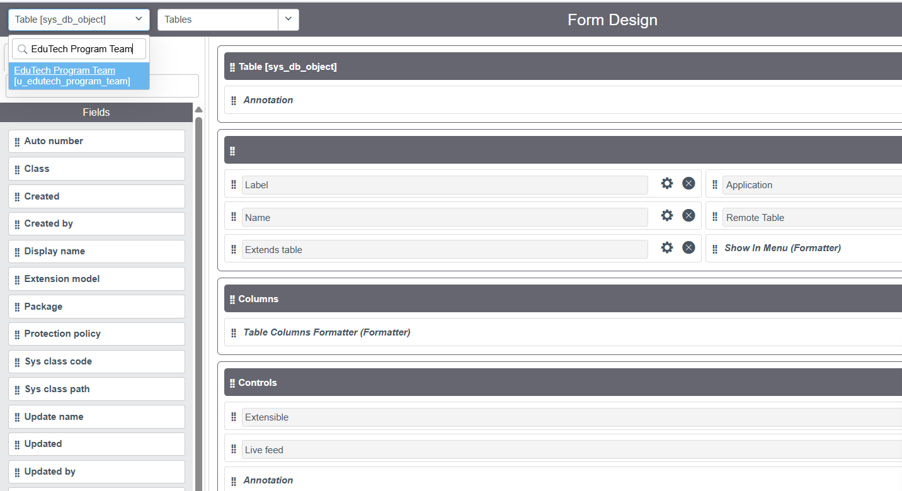

1. Drag and drop the fields to the left side as below.

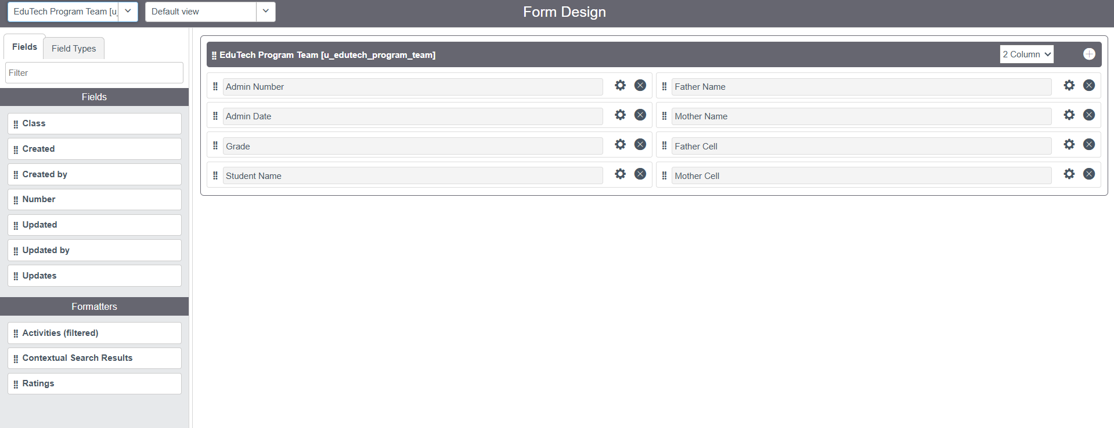

1. Save.

**Activity 2: Creating Form Design for Admission Table**

* 1. Follow the same steps as Activity1,Configure the fields as below and Save.

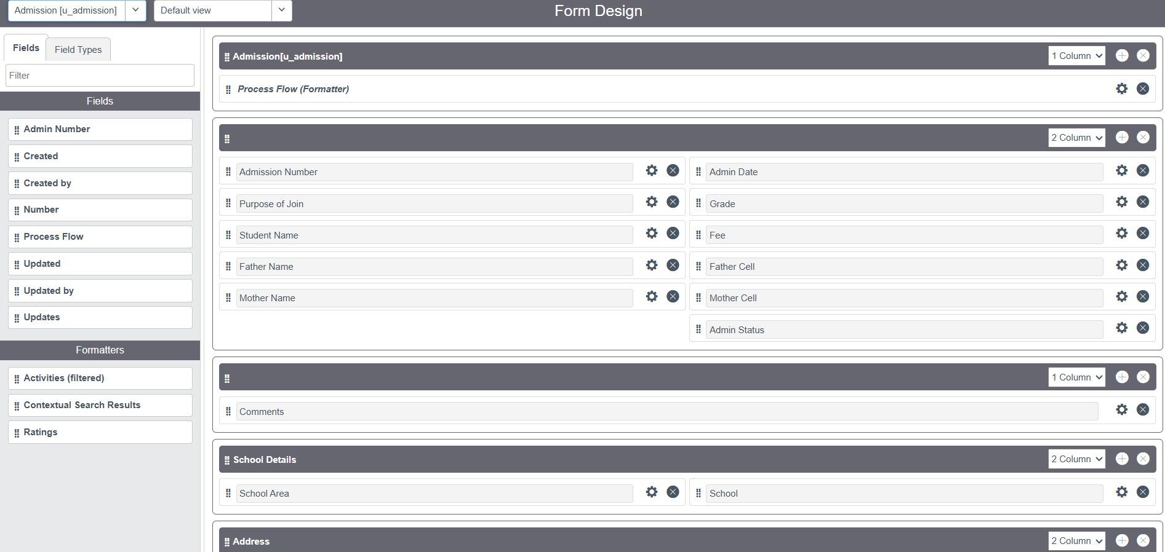

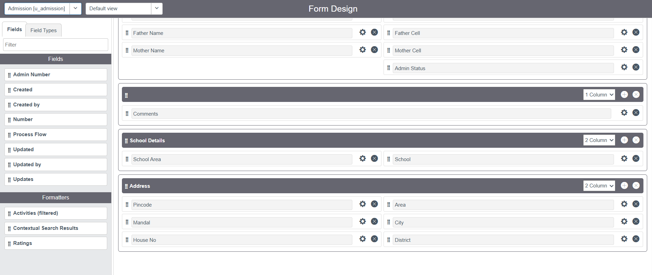

**Activity 3: Creating Form Design for Student progress Table**

* 1. Follow the same steps as Activity1,Configure the fields as below and Save.

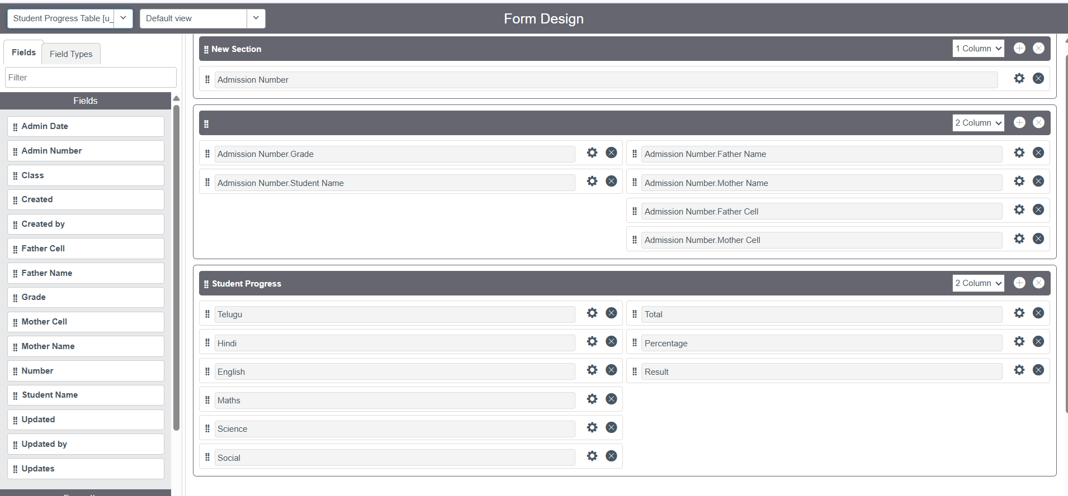

**Milestone 6: Number Maintenance**

**Activity 1: Creating Number Maintenance for Admin Number**

* 1. All >> Number Maintenance >> New

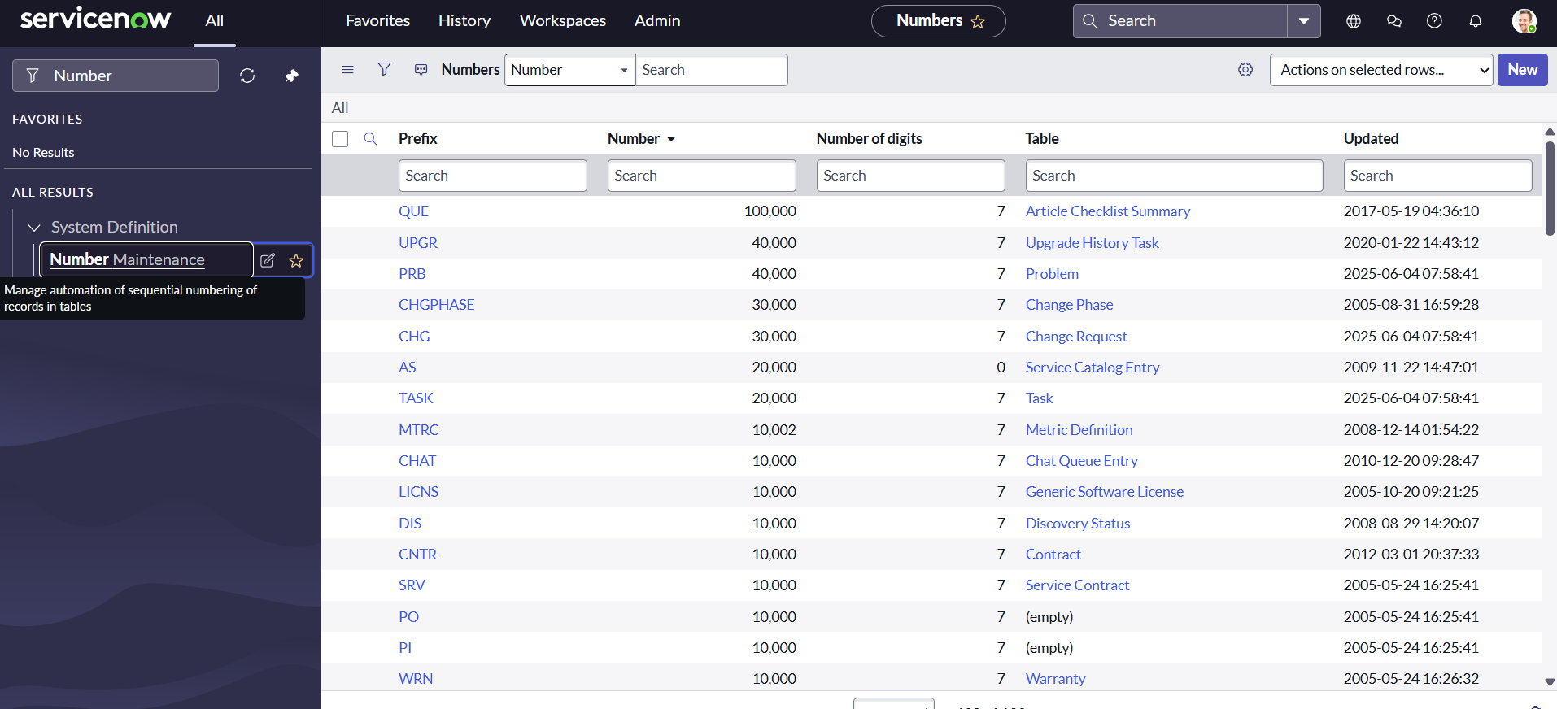

* 1. Fill the details >> Submit.

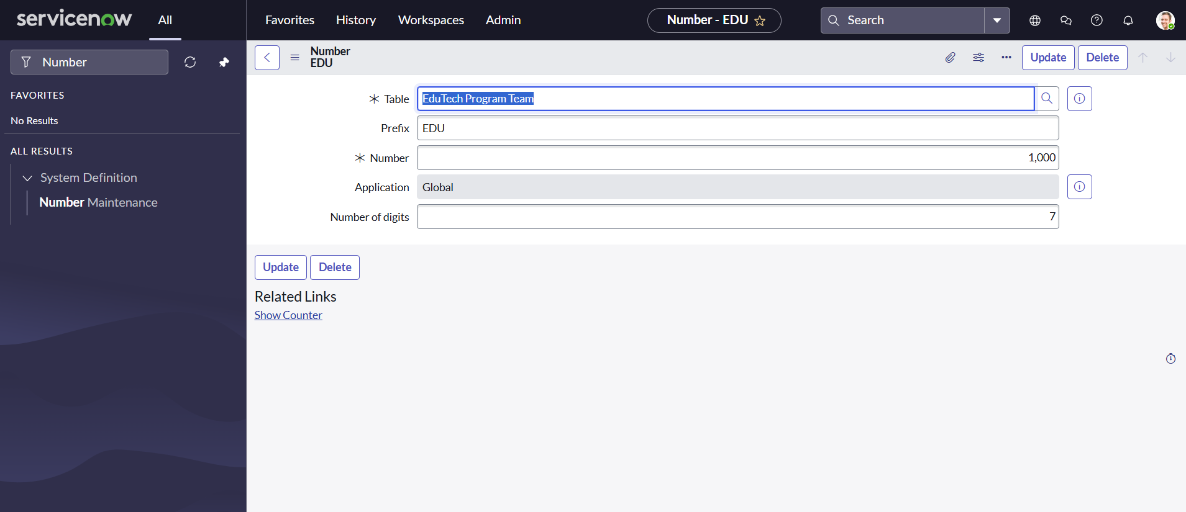

**Milestone 7: Process Flow**

**Activity 1: Creating Process Flow for Admission Table**

* 1. All >> Process Flow>> New.
  2. Fill the Details as given Below

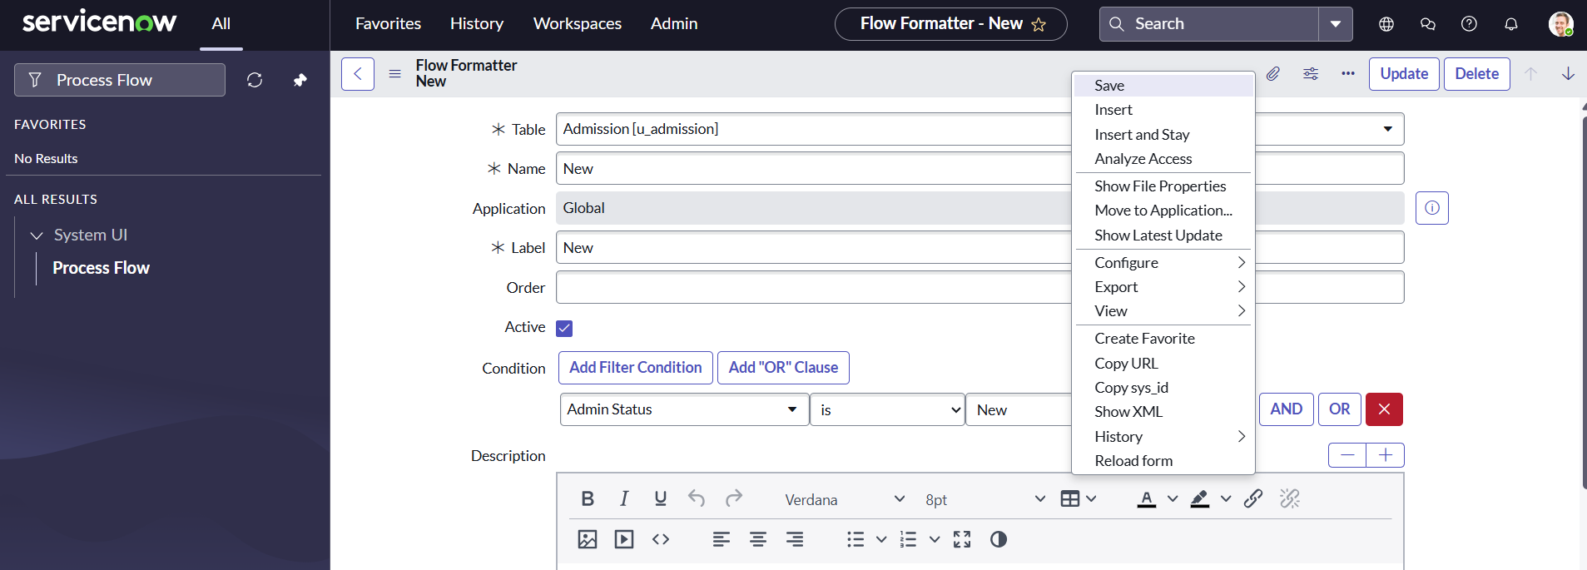

* 1. Right Click on toggle and click on the save .
  2. Replace the Name and Label as below and click on Insert on stay.

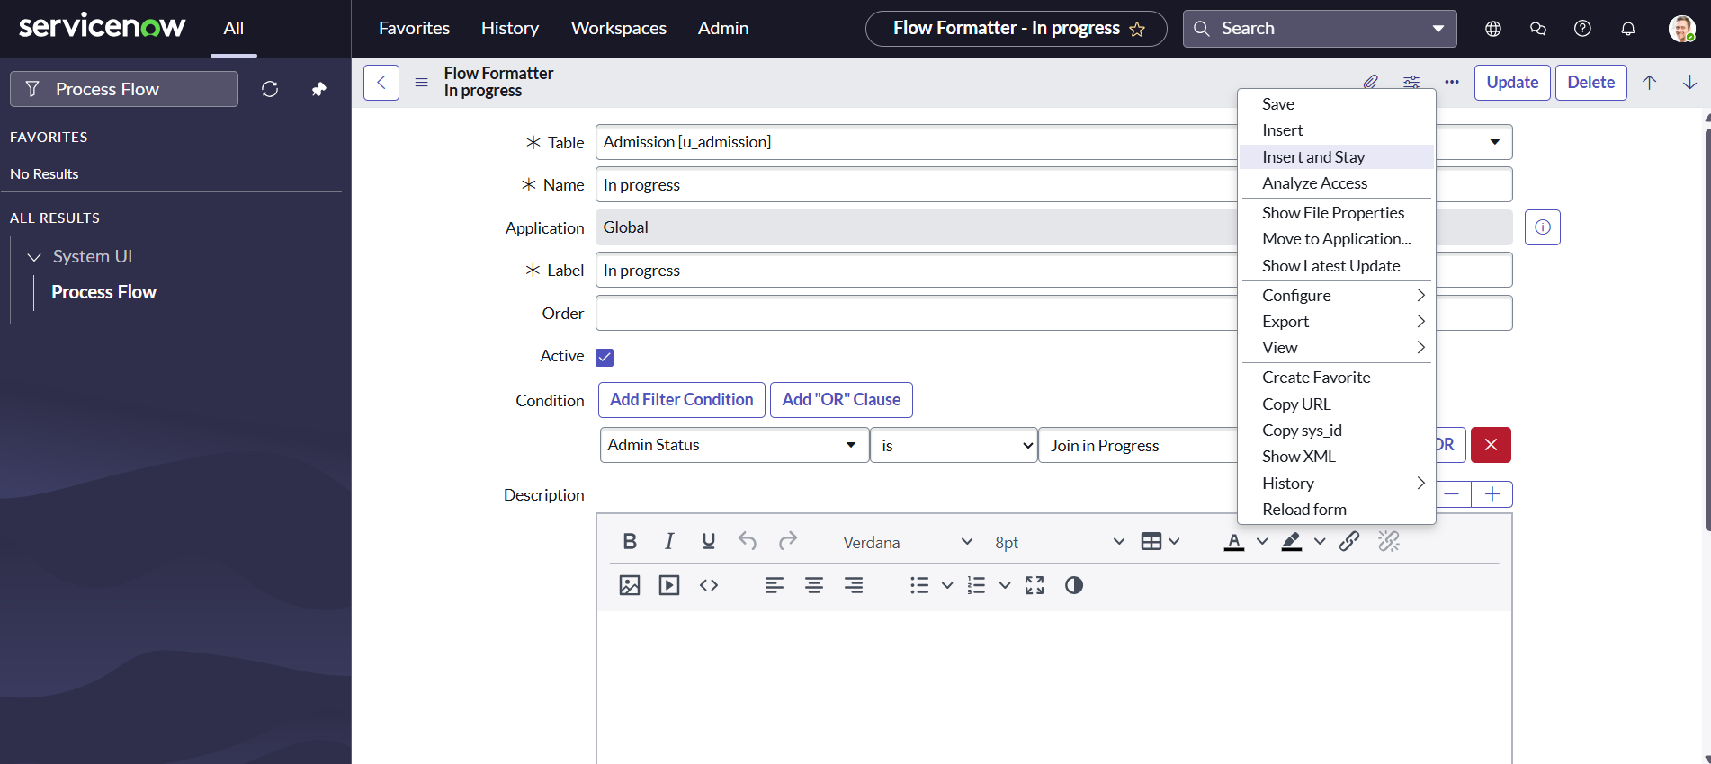

* 1. Replace the Name and Label in order and click on Insert on stay.

Joined >> Rejected >> Rejoined >> Closed >> Cancelled.

* 1. Order should be New >> InProgress >> Joined >> Rejected >> Rejoined >> Closed >> Cancelled.

**Milestone 8: Client Script**

**Activity 1: Creating “Auto populate” Client Scripts for Admission Table**

1. All >> Client Scripts >> New.

2. Fill the Details as given.

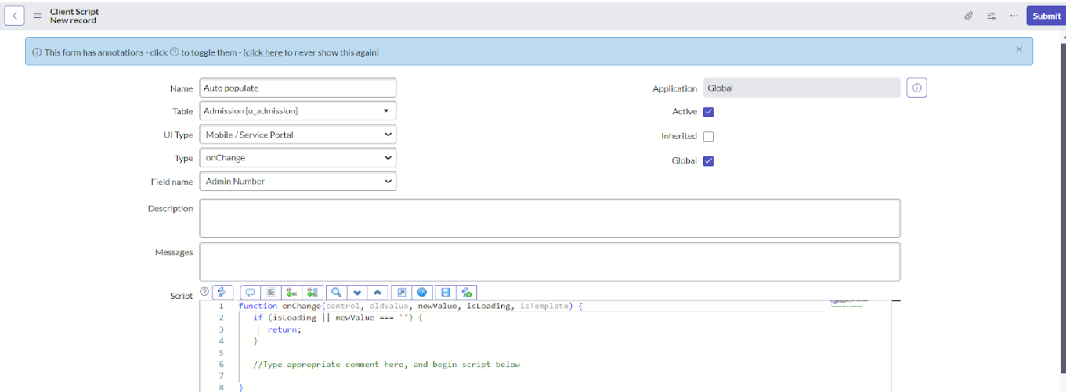

* 1. Write the Code as below, Enable Isolate script and Save.

function onChange(control, oldValue, newValue, isLoading, isTemplate) {

   if (isLoading || newValue === '') {

      return;

   }

   //Type appropriate comment here, and begin script below

   var a = g_form.getReference('u_admission_number');

   g_form.setValue('u_admin_date',a.u_admin_date);

   g_form.setValue('u_grade',a.u_grade);

   g_form.setValue('u_student_name',a.u_student_name);

   g_form.setValue('u_father_name',a.u_father_name);

   g_form.setValue('u_mother_name',a.u_mother_name);

   g_form.setValue('u_father_cell',a.u_father_cell);

   g_form.setValue('u_mother_cell',a.u_mother_cell);

   g_form.setDisabled('u_admin_date',a.u_admin_date);

   g_form.setDisabled('u_grade',a.u_grade);

   g_form.setDisabled('u_student_name',a.u_student_name);

   g_form.setDisabled('u_father_name',a.u_father_name);

   g_form.setDisabled('u_mother_name',a.u_mother_name);

   g_form.setDisabled('u_father_cell',a.u_father_cell);

   g_form.setDisabled('u_mother_cell',a.u_mother_cell);

}

Note: Make sure the Field names should be the same as you created .

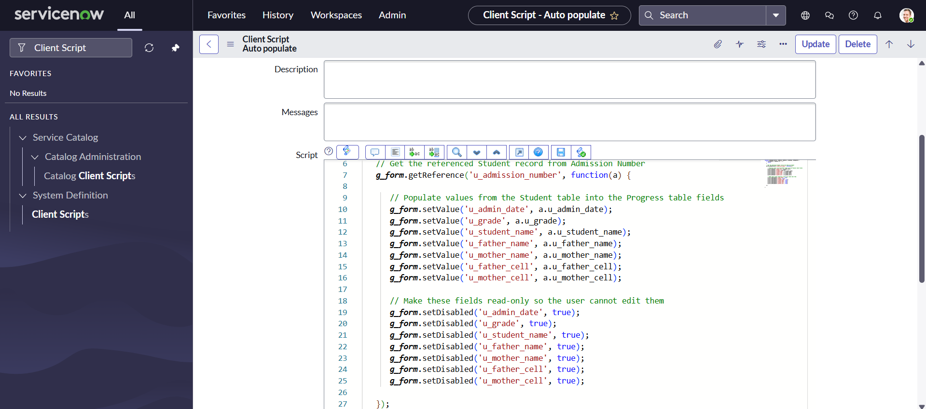

**Activity 2: Creating “Pincode Update” Client Scripts for Admission Table**

* 1. Fill the Details as given.

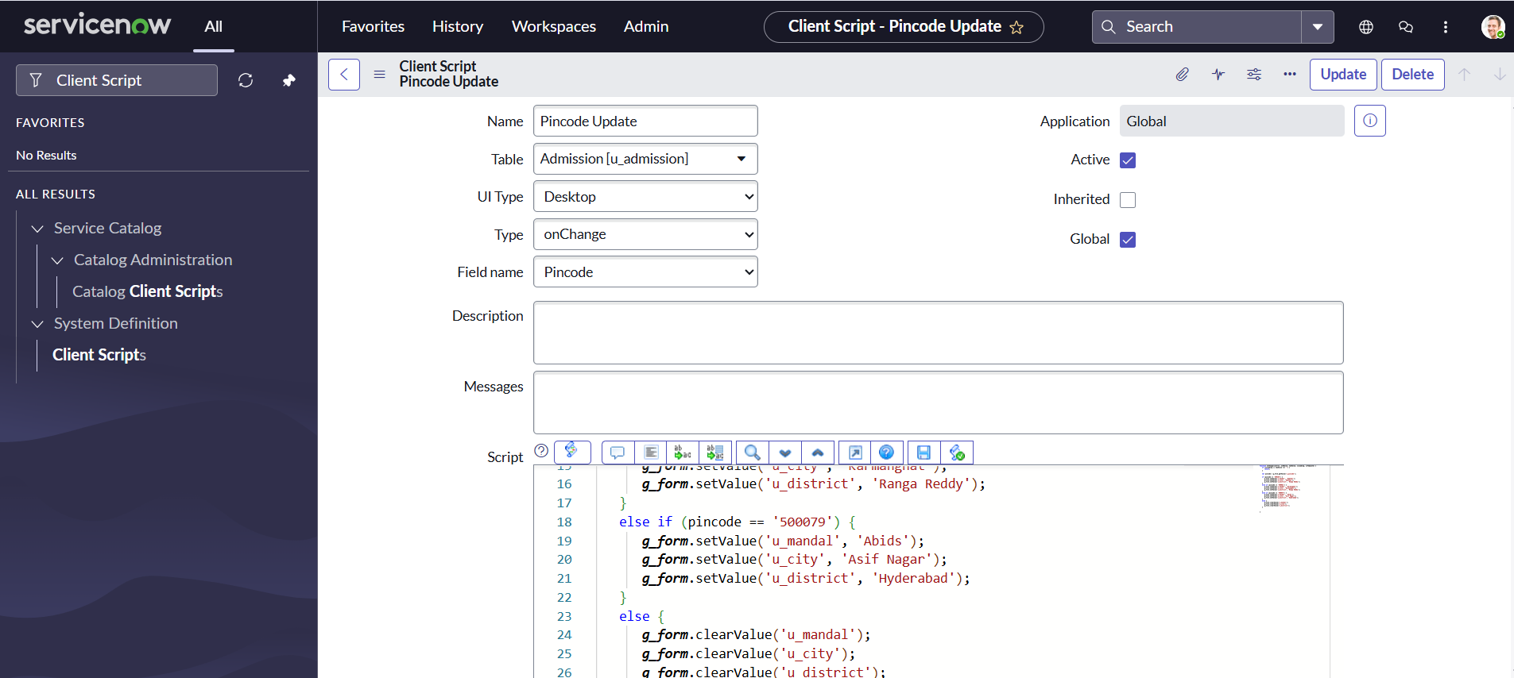

* 1. Write the Code as below, Enable Isolate script and Save.

function onChange(control, oldValue, newValue, isLoading, isTemplate) {

   if (isLoading || newValue === '') {

      return;

   }

    var a = g_form.getValue('u_pincode');

if(a == '509358')

{

g_form.setValue('u_mandal', 'kadthal');

g_form.setValue('u_city', 'kadthal');

g_form.setValue('u_district', 'RangaReddy');

}

else if(a == '500081')

{

g_form.setValue('u_mandal', 'karmanghat');

g_form.setValue('u_city', 'karmanghat');

g_form.setValue('u_district', 'RangaReddy');

}

else if(a == '500079')

{

g_form.setValue('u_mandal', 'Abids');

g_form.setValue('u_city', 'AsifNagar');

g_form.setValue('u_district', 'Hyderabad');

}

   //Type appropriate comment here, and begin script below

}

**Activity 3: Creating “Disable Fields” Client Scripts for Student progress Table**

1. Fill the Details as given.

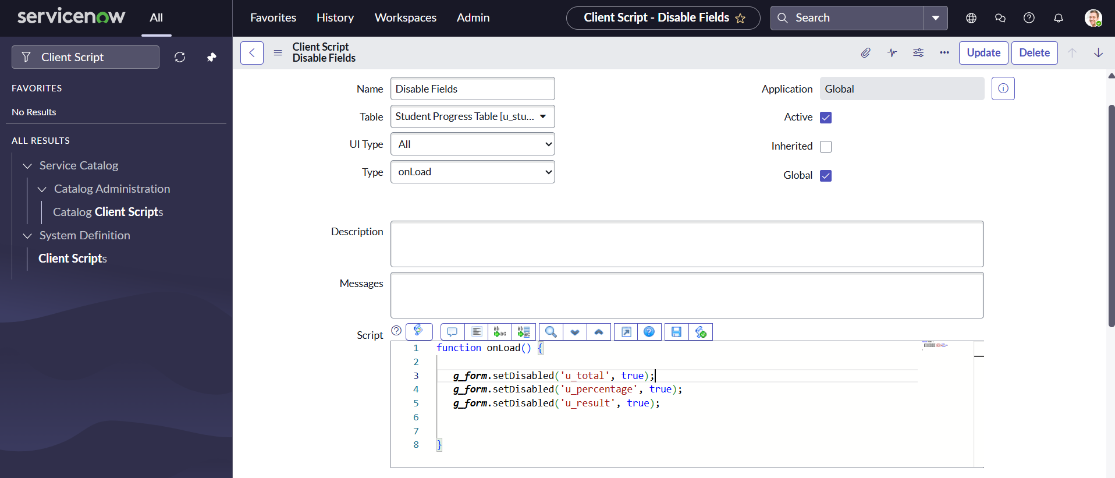

* 1. Write the Code as below, Enable Isolate script and Save.

function onLoad() {

   //Type appropriate comment here, and begin script below

   g_form.setDisabled('u_total',true);

   g_form.setDisabled('u_percentage',true);

   g_form.setDisabled('u_result',true);

}

**Activity 4: Creating “Total Update” Client Scripts for Student progress Table**

1. Fill the Details as given

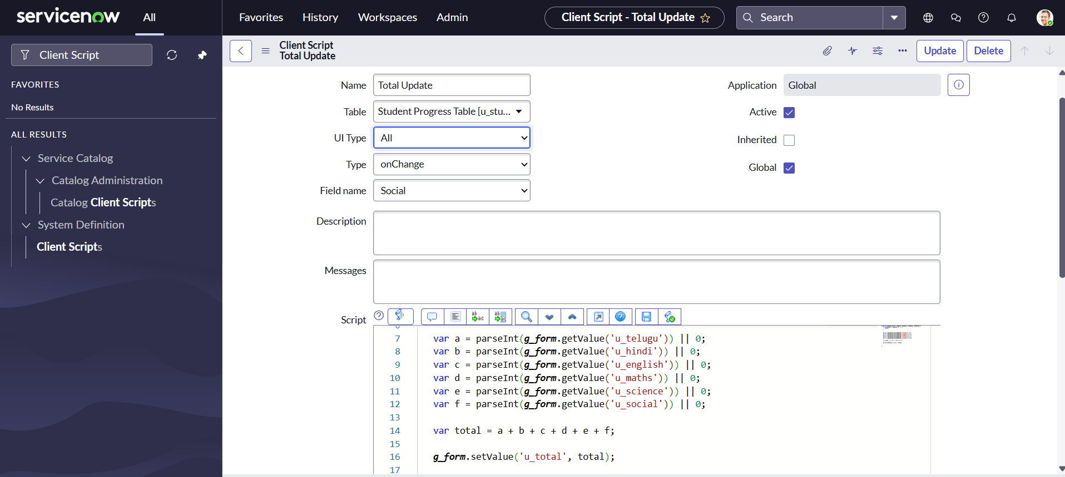

1. Write the Code as below, Enable Isolate script and Save.

function onChange(control, oldValue, newValue, isLoading, isTemplate) {

   if (isLoading || newValue === '') {

      return;

   }

   //Type appropriate comment here, and begin script below

if (newValue){

var a = parseInt(g_form.getValue('u_telugu'));

var b = parseInt(g_form.getValue('u_hindi'));

var c = parseInt(g_form.getValue('u_english'));

var d = parseInt(g_form.getValue('u_maths'));

var e = parseInt(g_form.getValue('u_science'));

var f = parseInt(g_form.getValue('u_social'));

var Total = parseInt(a+b+c+d+e+f);

g_form.setValue('u_total', Total);

}

}

**Activity 5: Creating “Result” Client Scripts for Student progress Table**

1. Fill the Details as given.

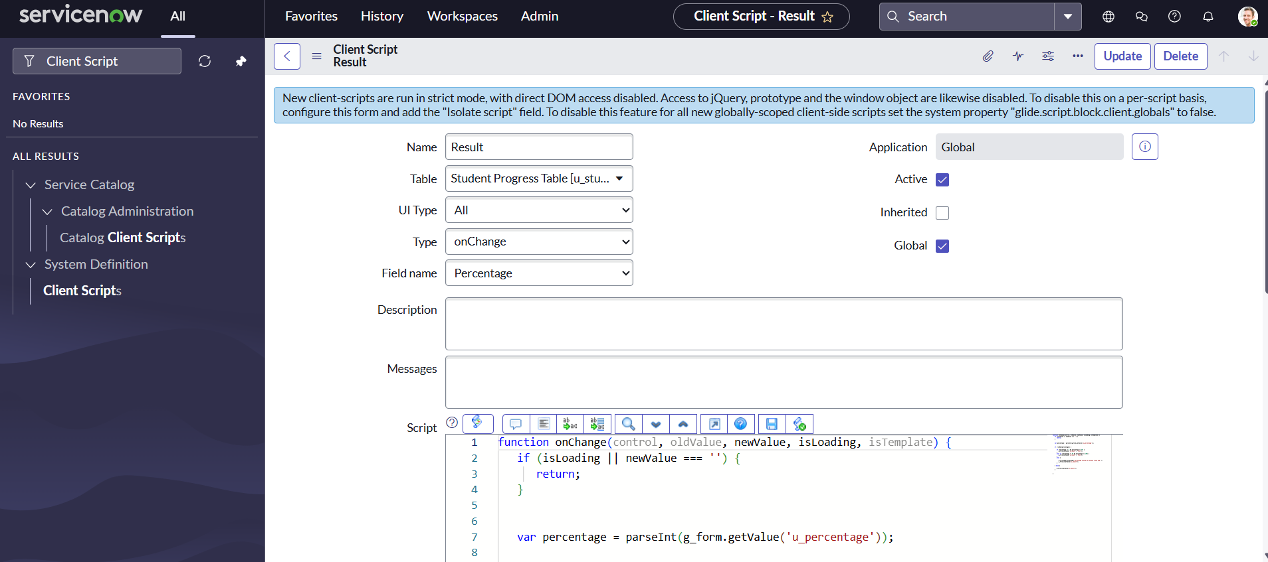

1. Write the Code as below, Enable Isolate script and Save.

function onChange(control, oldValue, newValue, isLoading, isTemplate) {

   if (isLoading || newValue === '') {

      return;

   }

   //Type appropriate comment here, and begin script below

   if(newValue) {

      var a = parseInt(g_form.getValue('u_percentage')); // Convert the value to an integer for comparison

      if(a >= 0 && a <= 59){

         g_form.setValue('u_result','Fail');

      } else if(a >= 60 && a <= 100) {

         g_form.setValue('u_result','Pass');

      } else {

         // Handle the case if a is out of range (optional)

         g_form.addErrorMessage('Percentage should be between 0 and 100.');

         g_form.clearValue('u_result');

      }

   }

}

**Activity 6: Creating “Percentage” Client Scripts for Student progress Table**

1. Fill the Details as given.

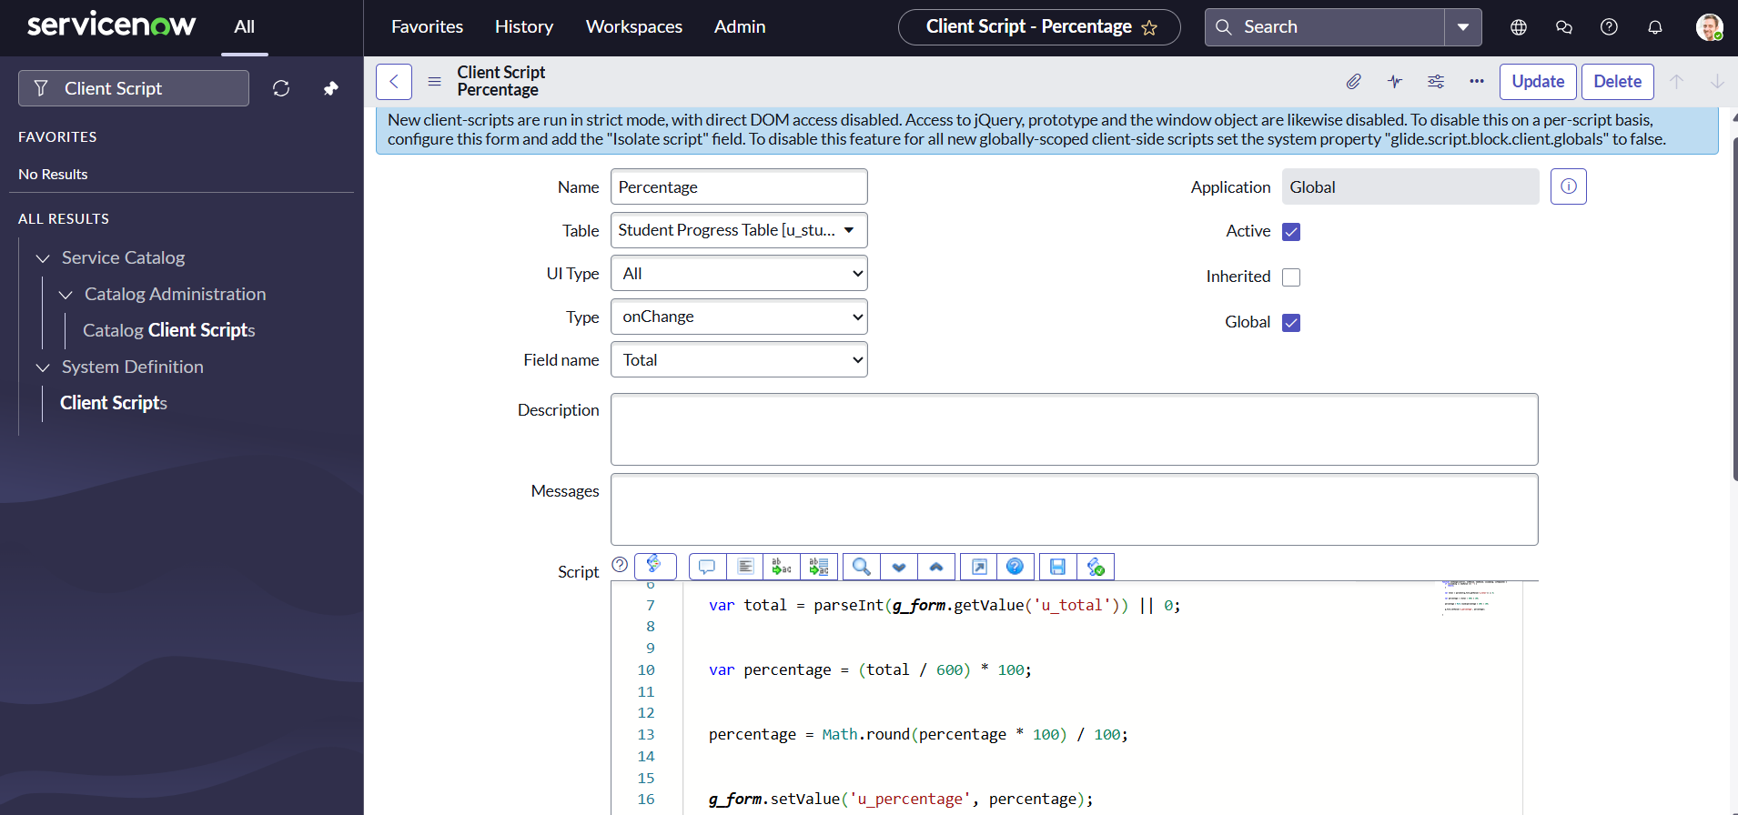

1. Write the Code as below, Enable Isolate script and Save.

function onChange(control, oldValue, newValue, isLoading, isTemplate) {

   if (isLoading || newValue === '') {

      return;

   }

   //Type appropriate comment here, and begin script below

   var Total = g_form.getValue('u_total');

   var Percentage = (Total/600)*100;

   g_form.setValue('u_percentage',Percentage+'%');

}

**Milestone 9: Result**

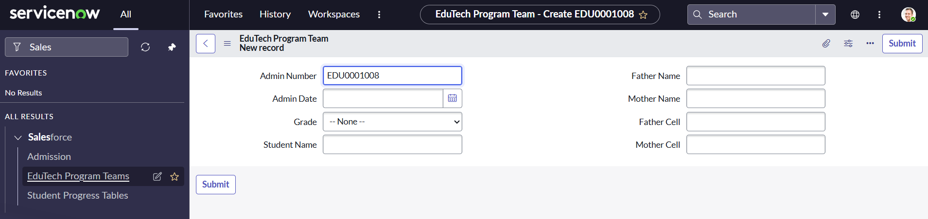

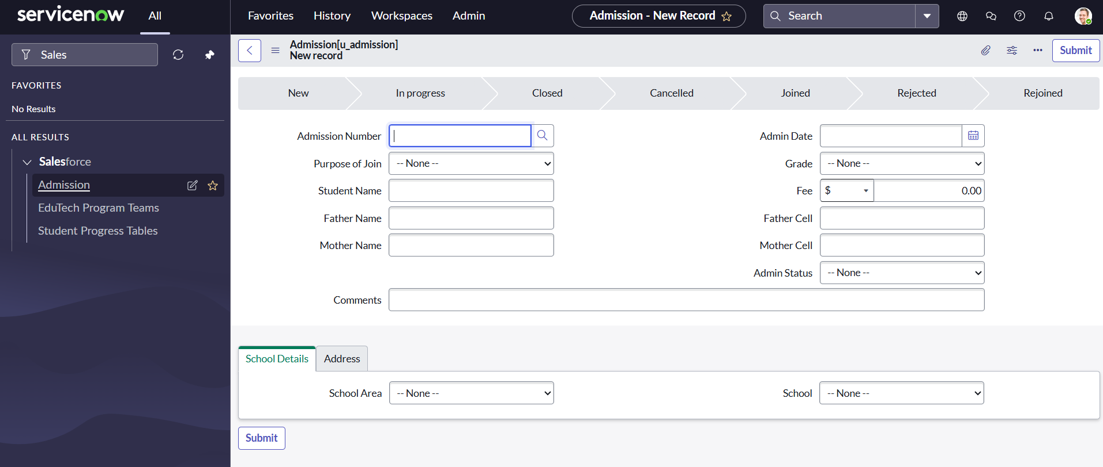

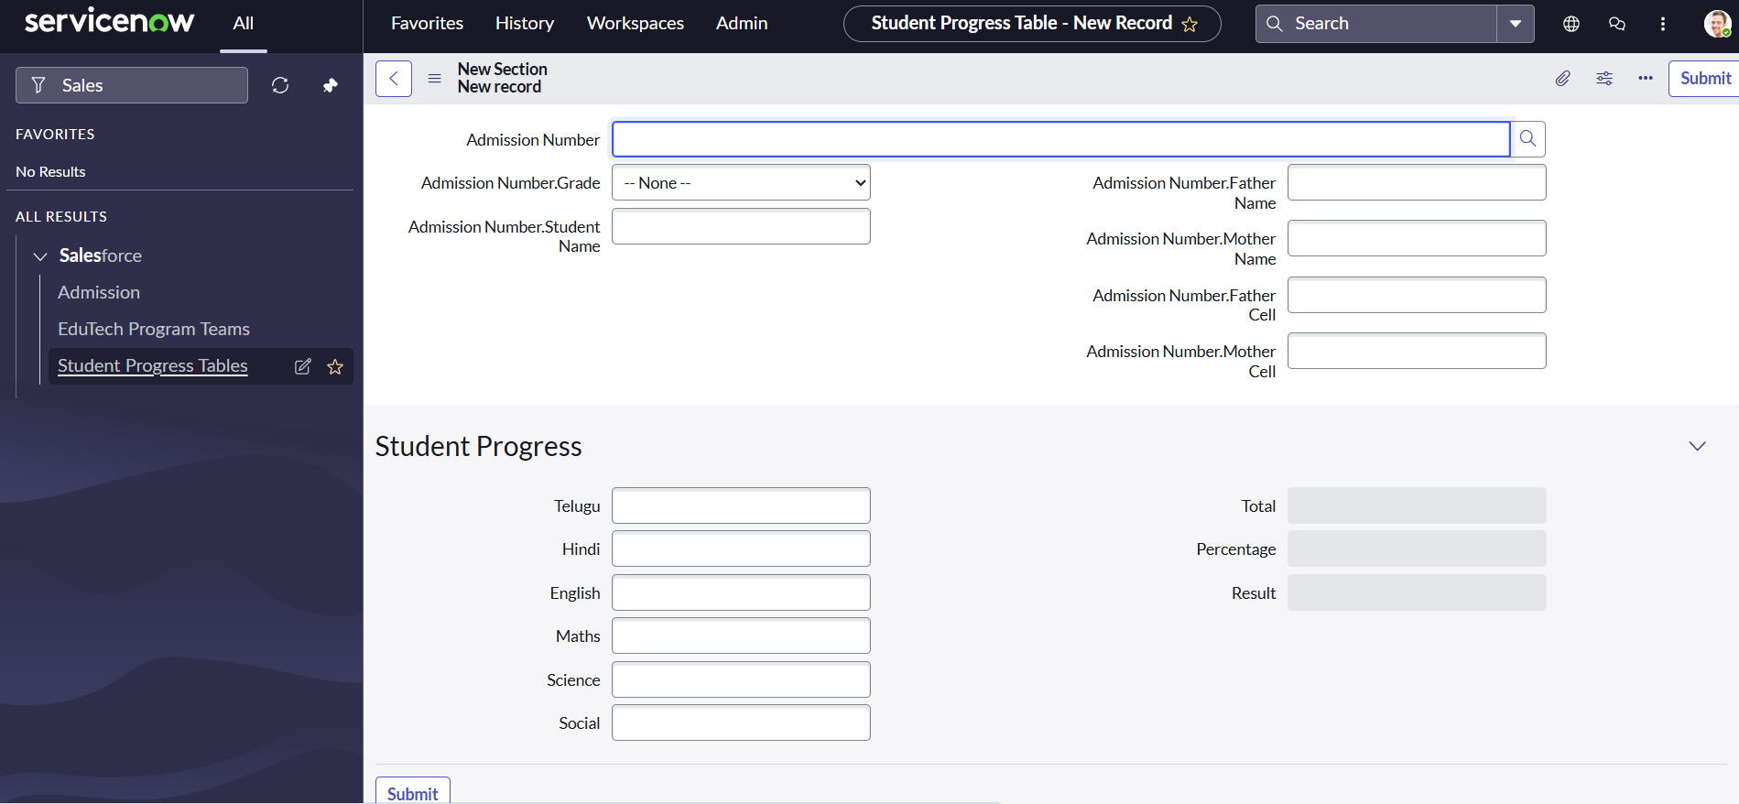

**Conclusion**

The project *“Education Organization Using ServiceNow”* successfully demonstrates how educational institutions can leverage ServiceNow to streamline academic and administrative operations. By implementing automated workflows, centralized user management, and efficient request handling, the system reduces manual efforts and minimizes errors. The integration of dashboards and reporting tools ensures data-driven decision-making, improving transparency and accountability across the organization.

This solution not only enhances communication between students, faculty, and administrators but also establishes a scalable and adaptable platform that can evolve with future institutional needs. Overall, the project highlights the effectiveness of ServiceNow in transforming traditional educational processes into a more efficient, collaborative, and technology-driven environment.